26.90: a) Fully charged:
b) 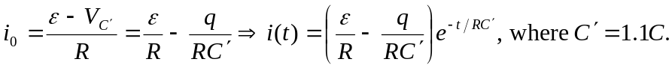
c) We need a resistance such that the current will be greater than 1 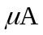 for longer than 
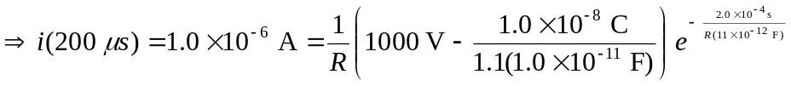
Solving for  numerically we find 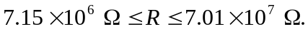
If the resistance is too small, then the capacitor discharges too quickly, and if the resistance is too large, the current is not large enough.

